4 Quality Assurance

4.1 quality control

In order to control the quality of the project, the development team will review what has been done at the end of each sprint. The quality of the product will be compared with the requirements. If discrepancies are found they will be discussed amongst the team in order to find a resolution. Development of the product will be following the list of acceptance tests in order to meet all acceptance criteria.

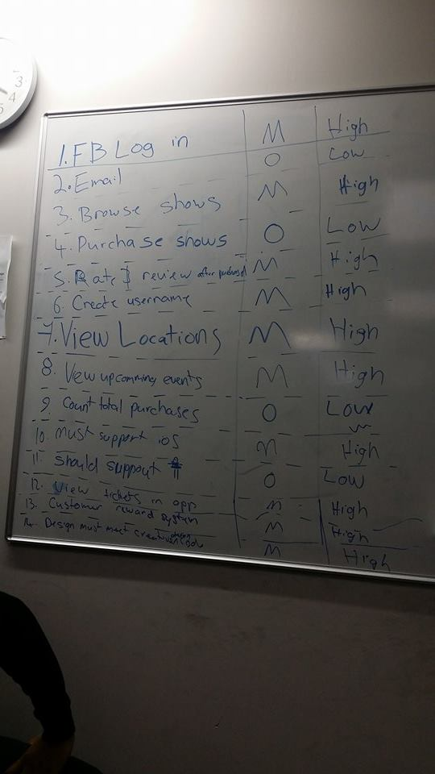

4.1.1 requirements

* The development team generated a list of requirements to guide each development team member. Unclear requirements will be discussed during the team & client meeting
* The development team must be adaptable to any changes made by the client
* Requirements were obtained by getting Epics by the Product Owner. Then they were broken down into User Stories. Acceptance tests will be made according to requirements and User Stories.

Requirement list from meetings--->

4.1.2 verification & validation

Assess the requirements to identify key performance areas of software. All members must check the function completion and verify the outcome. Cycle through Acceptance Tests for performance boundaries under stress conditions. Document Acceptance Test Results and plan the documentation of test tasks.

4.1.3 ui testing

The entire Development Team must always test the code for each allocated section. Usability tests must also be done by the client to check if it is user friendly and simple.

4.1.4 inspections and acceptance testing

Nearly complete activities that require inspections and/or acceptance testing will be specified in work documentation. Acceptance tests are from the user’s perspective and the external perspective of the system. Acceptance tests give acknowledgment to confirm how the condition of something changes.

Acceptance Testing should be conducted when necessary to verify that all required processes perform as planned.

4.1.5 coding

All code should be legible for easy error finding and understanding. All code must have its documentation and in code commenting for quality improvement.

4.1.6 documentation

All members in the Development Team must proof read and check to see if the documentation is readable.

4.1.7 meetings

* Meetings must occur at least once a week so that it give the Development Team Members the opportunity to discuss their current progress. Meetings are compulsory.
* Client must be met at least once every month to make sure everything is going according to what they initially wanted.

4.1.8 user story definition of done

* All acceptance criteria in acceptance tests for the User Story are met
* Code when required is annotated, legible, and is fully functional in accordance to the User Story.
* Functional acceptance testing is performed and tried by a team member (other than the sole creator of the code).
* A complete backup is made to the entire system.

4.1.9 sprint definition of done

* All User Stories included in the sprint are done
* All tests (that are applicable) including Acceptance Tests successfully pass
* No critical bugs exist in the end-of-sprint version
* A complete backup is made to the entire system

4.1.9.1 usability criteria

|  |  |
| --- | --- |
| Definition | |
| User Friendly | Easy to use from the Development Team’s and client’s perspective |
| Fast | Should not make the user irritate at loading times |
| No Critical Bugs | Should not contain bugs that negatively effects the experience of using main features of the product |

4.1.9.2 peer review

* Current progress needs to be reviewed by all other Development Team members. Peer review must occur at least once a week. The time before or after SCRUM meetings are recommended.
* Members being reviewed should make changes according to the review result.
* Face-to-face meetings are ideal for peer reviews, but it is acceptable to do peer review online if there are no exceptions.

4.1.9.3 client reivew

* Current progress of all members needs to be reviewed by the client at least once a month. Ensure the Development Team’s progress meets the client’s desired outcomes.
* The development team must make changes according to the results from the review.
* Recommended before or after client meetings.

4.2 deliverables

|  |  |  |
| --- | --- | --- |
| Phase | Deliverable | Description |
| Initiation | * Project Proposal * Requirements | The entire plan for the proposed project |
| Planning and Estimation | * Product Backlog * User Stories * Acceptance Tests * Sprint Backlog * Gantt Chart | The Product Backlog contains the list of deliverables for the product  User Stories contains the list of features the to be developed throughout the project  Acceptance Tests contain the list of situations and the expected response from the system  The Sprint Backlog contains the list of User Stories that are to be completed during the sprint  Gantt Chart is the chart about the schedule of the project. It also includes the detailed schedule for sprints, tasks and milestones. |
| Implementation | * Product Increment * Issue log * Risk log | The increment completion for each Sprint  The Issue log records the issue occurred throughout the project  The Risk log records the risks raised during the project |
| Review and Retrospect | * Functional Product Demonstration | Demonstration gives the Product Owner and opportunity to see and give feedback on the Product. Retrospect meeting will let the Development Team discuss the success/failures of the just concluded Sprint |
| Release | * Fully Functional Product | The full completed product |